Wingfield Wagyu

Design Implementation Report

Caleb Murphy

2022

Contents

Summary Of Implementation 2

Introduction 2

Summary of HTML 2

Summary of CSS 2

Summary of JavaScript 3

Challenges Faced 4

Lessons Learnt 4

Evaluation 4

Visibility of system status 4

Match between system and the real world 5

User control and freedom 5

Consistency and standards 5

Error prevention 6

Recognition rather than recall 6

Flexibility and efficiency of use 6

Aesthetic and minimalist design 6

Help users recognize, diagnose, and recover from errors and Help and documentation. 7

Future Work 7

# Summary Of Implementation

## Introduction

Wingfield Wagyu is a small cattle business that wishes to reach out wider than just a phone call. Through the implementation of a website, they will be visible to the public farmers and customers of all backgrounds will not have as big of a barrier to get in contact with this small business from western Queensland. Even the service provider will have an easier time getting in contact with the business, allowing for easier description of where the business is located and how to get in contact with the business.

## Summary of HTML

Each webpage starts off with the link to their respective style sheet as well as the font being used. The next thing that every webpage is the navigation bar, which used the built in nav element, as well as the title for the webpage. Apart from the index.html page, every page has the same format of the page name overlayed over their respective cover photos.

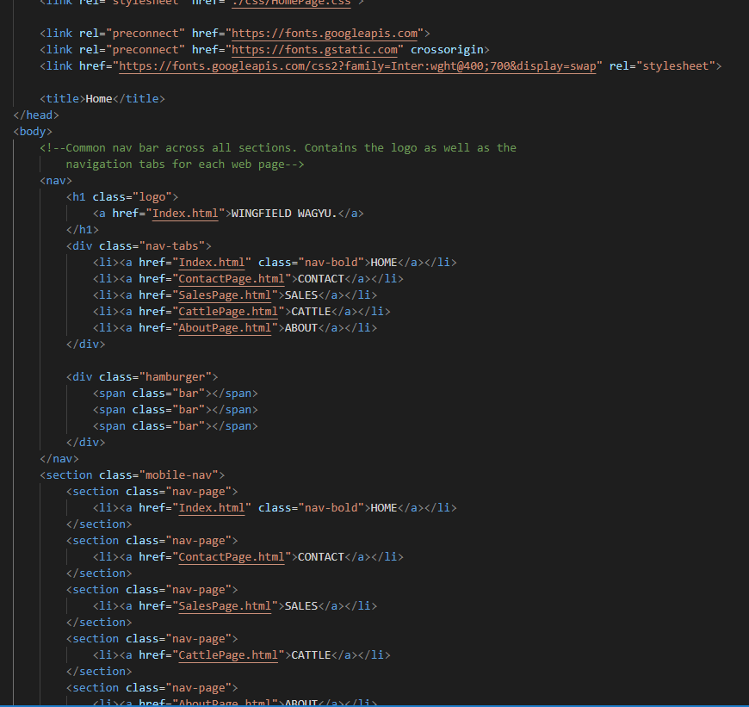

Figure 1: HTML Structure example

The structure of the webpage was to divide everything in the webpage into their own boxes that could then be individually manipulated. Most things were sectioned using the section element with the article element being used when large pieces of text were used.

Lastly each webpage contained a footer that used the footer element built into HTML 5.

When designing the navigation bar, essentially 2 nav bars had to be used since there was a desktop design as well as a mobile design with only 1 design being shown at a time. This is talked about further, later in the document.

## Summary of CSS

When designing the CSS for the website, there were several different style sheets that were used. The main style sheet contained any overlapping styling that would be used by most of the webpages. This approach helped stopped the duplication of styling and allowed for a more consistent design of the website.

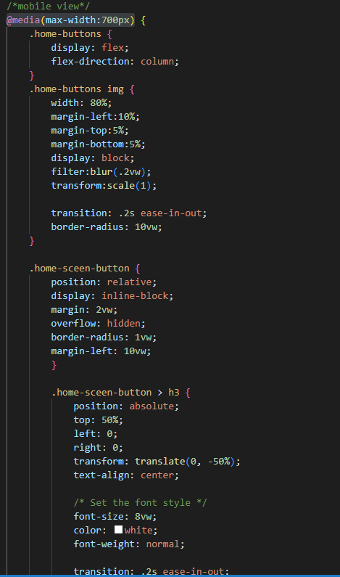

Figure 2: CSS media handle example

The initial design of the website was for a desktop, but this website was also intended to be viewed on a mobile device. To allow for this, the media handle was used through the CSS documents to change the styling and scaling of the webpage based on the screen size. In this case, 700px was used as the cut-off from desktop viewing and the transition to the mobile view of the website.

Animations were also used throughout the design of the website to add to the viewing experience. Hover animations on the home buttons are an example of this. Using the handle “hover” certain styling aspects were able to be changed when the user hovered their mouse over the button. Aspects such as the increasing the scale and removing the blur effect on the image were used as well as increasing the size of the text overlay. This had the benefit of letting the user see visual feedback of what they were hovering over as well as be able to see what they are hovering over more clearly.

To help with these animations, the “ease-in-and-out” transition was used, which allows for setting the duration of the animation instead of the final state being jumped to. This also allows for intricate animation curves in need be, but these were not explored in this website design.

## Summary of JavaScript

JavaScript is powerful tool that can add so much to a website. In the Wingfield Wagyu website, JavaScript was a powerful tool in adding many features to the website. The first feature that the user will see, is the typewriter effect that “types” in the title for the website. To implement this, different features had to be added to the html to access the element through JavaScript.

Figure 3: CSS animation example with ease-in-out transition

The second implementation of JavaScript that was used, was in the form validation on the contact page. This type of form validation involved adding and removing classes from each input field depending on what the user had inputted into the field. For the name and message field, it was as simple as adding an ‘error’ class or adding a ‘correct’ class depending on if the user had inputted into the field.

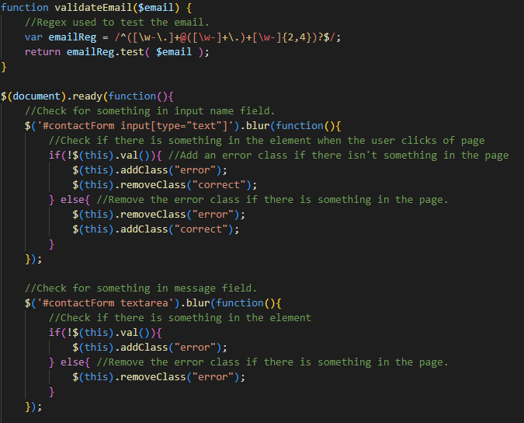

Figure 4: JavaScript form validation example

The email section on the other hand required a little more work. In this case, a function was made to check the validity of the email using Regex. This checks to make sure that the user has including things such as an ‘@’ symbol and a ‘.com’. This feature allows the user to not only know that what they inputted into the input field is wrong, but also what they need to change to fix it.

Figure 5: JavaScript modal code example

The third implementation of JavaScript on the website is the use of modals when submitting the input fields on the contact page. This required accessing the modal classes and determining when to display them as well as when to remove them. In this case, if the outside screen is clicked by the user, then the main modal would be removed. But if the yes or no buttons were clicked, then the main modal would still be removed, but another modal displaying whether the message was sent or not would then be displayed and only after clicking the screen again would this modal disappear.

Finally, the last implementation of JavaScript was the use of the hamburger menu on the mobile view of the website. JavaScript, in this case, was used to determine whether the hamburger menu was clicked as well as tell the style sheet to activate the menu and show it to the user.

# Challenges Faced

Many of the challenges faced were due to a lack of confidence in html. This caused some second guess of how to implement certain features. This started with using the media function to make the mobile version of the navigation bar. This process included hiding the desktop navigation bar to show the new hamburger menu design. What made this process difficult was that this had to be made over the top of the desktop application as the desktop nav bar still needed to work. Furthermore, pushing the tabs in the hamburger menu to the right also took a lot of work. In the end, setting a solid foundation and consistent encapsulation allowed for me to overcome this challenge.

The next challenge was also located on the home page. The challenge was from attempting to put the home page title over the top of the image and then also allowing this to scale with the screen and stay in the middle. The solution that I kept coming back to with this problem was to use percentages and view widths instead of pixel values. This allowed for a consistent scale of the webpage regardless of the screen size. So, with this knowledge applied to every part of the process, as well as a lot of research and tutorials, I managed to make the title in the centre constantly. This logic was then able to be used in all the other webpages.

Speaking of the other webpages, they also held a lot of challenges. The contact page was made first and the most complete part of the process was the input forms for the user to use to contact the business owner. The main challenge I faced was stopping the input form from submitting when the user pressed the enter key. I only wished the user to submit the application when they click the submit button. What made this hard was that this process was built in by default, so it took a lot of research and trial and error to get to the final product.

Another complex part of the assignment was the cattle page. This was a very long webpage and to keep consistency as well as reduce the workload, the HTML and CSS had to be made to allow for a range of different animals as well as different quantities of those animals. The practicals in class showed how flex box could be used to display these animals in a consistent and readable manner. After going through the practicals, the solution was eventually found.

The main CSS document, style.css, is used by all webpages and this was how it was intended. What was challenging was making the webpage to use as little CSS as possible as this would allow for a more consistent design for the webpage. So, this document holds most of the CSS used in the webpage such as the title CSS.

# Lessons Learnt

Each of the challenges that were faced caused a layer of research to be conducted to fully understand the problem. I found that taking a slow and methodical approach to each page allowed me to implement efficiently and correctly without the need to revise code. Testing out my code on another website allowed me to be creative without the worry of ruining my website. Furthermore, I have found the having a solid foundation like a medium fidelity prototype really helps in the design process and understanding the way the html would be structured. After going through the practicals thoroughly, I ended up finding a base understanding that helped me through a lot of the problems.

# Graphical user interface, text, application Description automatically generatedEvaluation

Figure 6: Visibility of system status when input field not complete

## Visibility of system status

In the Contact Page of the website, if the user clicks the input form but then does not put anything in it, there is a border that gets added around the input field. Once the user recognises their mistake, a green border is added instead allowing the user to see that what they have inputted into the system is correct. Furthermore, the email input field also has a check that makes sure there are the essential characters for a valid email. If the user puts in an email that does not fit this criterion the website tells the user that what they inputted is incorrect and allows them to change it.

## Match between system and the real world

It is important to bring as much of the real world into the website as you can, and this website does that. When using the website there a lot of references to the real world. The main one is the use of the word home in the navigation bar. Home is the place people often associate with where they started their journey, and in this case, their journey through the website which stated on the home page. Another match between the system and the real word is when the user accesses the sales page, they see an image of a farmer holding a bull which is what a lot of people associate with a cattle sale. This allows the customers have a prebuilt idea of what that webpage is about.

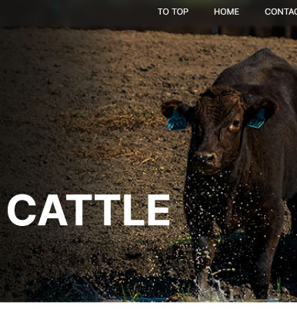

Figure 7: To Top link in the nav bar

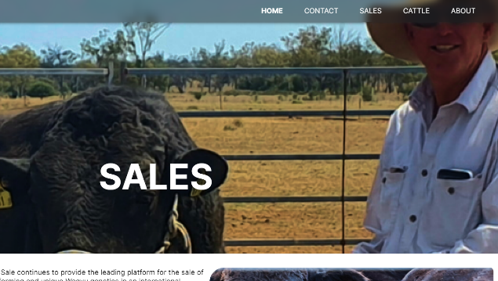

Figure 8: Sales Page containing farmer holding bull cover image

## User control and freedom

In the Cattle Page, the user can click on a section to scroll to that section of the webpage. This can sometimes scroll quite a distance which can be problematic if the user presses the wrong section or wishes to return to the top of the page. To fix this, the user can go back up to the top of the page by pressing the ‘TO TOP’ link next in the nav bar. This allows the user to quickly recover from their mistakes.

In the Contact page when the user attempts to submit a message, they are asked if they are sure they wish to quit, if the user presses no after realising they submitted the wrong message there are no consequences. This fosters a sense of freedom and confidence in the user. Quick exits allow users to remain in control of the system and avoid frustration.

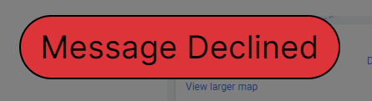

Figure 9: Message Declined after pressing no to submit

## Consistency and standards

The navigation bar is a constant element of each webpage throughout the website. The only part of the navigation bar that changes is what page is emboldened which shows the user where they are in the system. Secondly, the buttons on the home page that lead to their own respective page on the website also contain each page’s respective cover photo to give some constancy between changing webpages and it also shows that the user clicked the webpage that they want. Thirdly, the scaling of the webpage is the same regardless of the screen size allowing for the same experience regardless of the device the website is being viewed in. Lastly, the hamburger is a standard that is help up by a lot of webpages. This is universally considered a menu. The use of this as well as transforming it into an when clicked allows for a seamless navigation experience as the user would have done this process many times before.

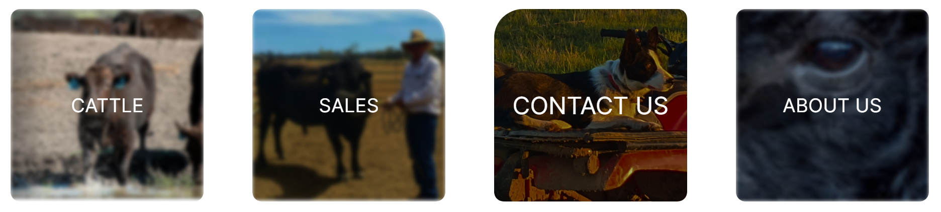

Figure 10: Home Button Page Links

## Error prevention

When the user forgets to input information into an input field, the input field is outlined in red, and the user is unable to submit their form. Furthermore, in the email input field, if the users email address does not fit the criterion of an email address, they are also given a warning displaying the correct format for an email. This helps stop the user from making an error when attempting to talk with the owner of the business. If the user finally submits the message they wish to send, they are then asked if they are sure they want to submit the message with their message underneath for them to review. Upon revision of their message, if they are happy with it, they can press submit.

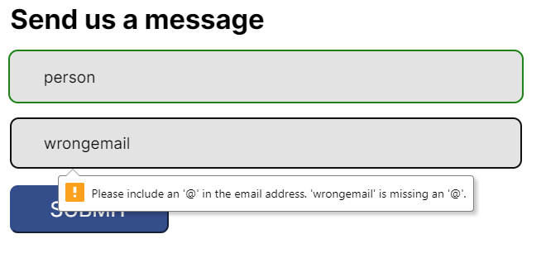

Figure 11: Feedback when wrong email is submitted

## Recognition rather than recall

When the user first enters the home page, they are met with a wagyu bull, displaying to the user what the website is about: Wagyu cattle. If they then scroll down, they are met with another set of images with a text overlay telling the user where the page goes, but also there is an image showing the user were the button leads also. For example, the cattle button uses an image of cattle. Furthermore, the navigation bar in the top right has a hamburger menu (in the mobile view) that when clicked, transforms into an X. This is a common symbol that often means close or cancel and allows for a more learnable website as user will know the meaning without having used the website previously.

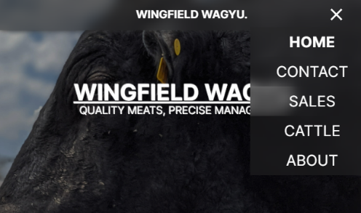

Figure 12: Hamburger Menu replaced with a cross

## Flexibility and efficiency of use

When the users browse pages such as the cattle page, which can often be a long page that is tedious to navigate, they are able to use section headings that link to parts of the page. This is often much faster than scrolling and will benefit more experienced users when navigating the page. Through adding multiple ways to navigate around the website, users can use the website in different ways depending on their intentions.

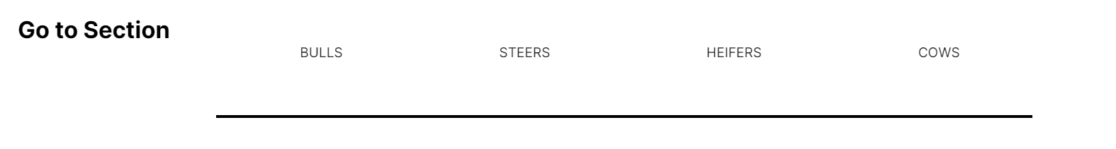

Figure 13: Section headings in the cattle page

## Graphical user interface, website Description automatically generatedAesthetic and minimalist design

Figure 14: Mobile design of the website home page

The aim of a website design is to ease the user into information. So, information should not be thrown into their face, but instead they should be given small pieces at a time and slowly reveal that information as they want it. For example, the hamburger menu is originally just three bars that don’t take up much room as well as not giving the users much information. But when the user clicks the menu, they are met with all the pages they can travel to on the website. Furthermore, on the homepage, they originally just see the navigation menu and the title of the website, but when they move down the page, they can see the different buttons to each webpage (Refer to Figure 10). These buttons also only show the names of the webpage they will be taken too, if they want more information, they can click the button and get taken to that webpage.

## Help users recognize, diagnose, and recover from errors and Help and documentation.

When a user presses a section heading in the cattle page, they can often get taken quite far down the page and this can be quite frustrating to recover from. In this website, the user can press a link in the navigation bar that takes them to the top of the screen again where they can continue their browsing experience (Refer to Figure 7). Furthermore, the user is given tips and feedback when filling out their form to contact the business. This helps them recover from any errors they may have made when filling out their message form. This message can also have questions about how to recover from any other errors in the system if the website does not help them through it. The user can then message the owner of the business directly to sort out the problem and hopefully update the system to stop the error happening again. This allows for more specific design problems to be updated quickly.

# Conclusions

This project was the result of Wingfield Wagyu struggling to reach out to the cattle community and show off their most prized animals. Now, a website has been created that allows this company to be in direct contact with their customers as well as allowing said customers to find the business. Through HTML, CSS and JavaScript, a responsive design was created that includes multiple pages as well as animations and form validation. The website, created through multiple rounds of low, medium and high-fidelity prototyping, was eventually created and can now be successfully implemented into the businesses core advertising platform. This will result in Wingfield Wagyu receiving a high influx of customers reaching out to their business and a more personal connection to those customers.

# Future Work

The future work needed for the website includes allowing the user to show interest in a sale. This would include a button at the bottom of the webpage that would show their interest in the sale and show to the business that there is interest. This also touches on the second element that needs to be implemented, the business being able to receive information on who exactly has shown interest in an animal. As currently they business knows that there is interest but has no way of getting in touch with that person. To solve this problem, the user could be able to log into the website to have their details saved and allow for a more effective browsing experience and get in touch with the business owner faster. The last part of the webpage that still needs to be added is the ability for the user to go from the website to the Wagyu Association and display the animal that they are looking for as well as its credentials. This would allow the customer to view more information on the animal and know that it comes from a credible source.